**Priority based energy and delay efficient MAC protocol**

A Report submitted to the

Department of Computer Science and Engineering, IUBAT

in partial fulfillment of the requirements for the degree of

B.Sc. in Computer Science and Engineering

By

|  |  |  |
| --- | --- | --- |
| 1 | Md. Shahadat Hossain | 16103112 |
| 2 | Rupol Ahmed | 16103342 |

Supervised by

**Md. Mortuza Hossain**

Faculty, Department of CSE



DEPARTMENT OF COMPUTER SCIENCE AND ENGINEERING

International University of Business Agriculture and Technology

# ABSTRACT

The present need for a well-organized and continuous health care service at an affordable price gives rise to a wireless health monitoring technology. Wireless body area network is an emerging field of a wireless sensor network that works in the vicinity of the human body. This technology has its most significant application in the modern healthcare system. This WBAN architecture is designed to get the health information and daily routine of human activity (both physical and psychological) through energy efficient and reliable radio transceivers connectivity These modern devices behave according to some predesigned rules called communication protocols. The MAC protocols are designed specially according to WBAN standards and requirements.

The physiological sensors installed in WBAN system consume a large amount of energy for communication that leads to frequent data interruption and also a change of implanted devices. As this is troublesome for both patient and server, protocols are continuously upgraded to make the communication highly energy efficient and reliable.

The prime aim of this work is to reduce the energy consumption and delay. This work proposes an energy harvesting adaptive MAC protocol applied for node connectivity and detailed simulation study carried out with the proposed protocol proves to be having minimum power consumption, increased network lifetime, and high throughput compared to the existing MAC protocols in WBAN framework.

# DECLARATION

The research work entitled “**Priority based energy and delay efficient MAC protocol**” has been carried out in the Department of Computer Science and Engineering, IUBAT is original and conforms the regulations of this University.

I understand the University’s policy on plagiarism and declare that no part of this report has been copied from other sources or been previously submitted elsewhere for the award of any degree or diploma.

Md. Shahadat Hossain Rupol Ahmed

ID: 16103112 ID: 16103342

**Supervisor Sign**

**Md. Mortuza Hossain**

Faculty, Department of CSE

# ACKNOWLEDGEMENT

We would like to express our deep and sincere gratitude to our supervisor, **Md. Mortuza Hossain,** Facultyof Department of Computer Science & Engineering, for her unflagging support and continuous encouragement throughout the thesis work. Without his guidance and persistent help this report would not have been possible.

We must acknowledge the faculties and staffs of Computer Science & Engineering for supporting us to do this thesis Report.

We are especially grateful to **Professor Dr Abdur Rab,** Vice-Chancellor of **IUBAT-International University of Business Agriculture and Technology,** and **Dr. Utpal Kanti Das,** Coordinator of CSE-Computer Science & Engineering for giving us good advice, inspiration to complete our report.

Last but not least, we would like to convey our gratitude to all our faculty members of IUBAT, friends and who gave us good advice, suggestions, inspiration and support to complete this report.

Contents

ABSTRACT ii

DECLARATION iii

ACKNOWLEDGEMENT iv

INTRODUCTION 1

1.1 Background and rationale of the Study 2

1.2 WIRELESS BODY AREA NETWORKS 3

1.2.1 Architecture of WBAN 4

1.2.2 Hardware platform 4

1.2.3 BAN Communication Technology 5

1.2.4 Sensors Distribution 5

1.2.5 Physical Environment 5

1.2.6 Energy Source 5

1.3 Application of BAN 5

1.3.1 Medical 6

1.4 Design Requirements 6

1.4.1 Data rate 6

1.4.2 Energy Effective 7

1.4.3 Reliability 7

1.4.4 Scalability 8

1.4.5 Quality of Service (QoS) 8

1.5 Cause Of Energy Wastage 8

1.6 Medium access control layer 10

1.6.1 Overview of IEEE 802.15.6 MAC Layer 10

1.6.2 Medium Access Control protocols 10

1.6.3 TDMA And CSMA/CA 12

LITERATURE REVIEW 13

2.1 A SURVEY ON WIRELESS BODY AREA NETWORKS FOR EHEALTHCARE SYSTEMS IN RESIDENTIAL ENVIRONMENTS [1] 14

2.2 PRIORITY BASED WIRELESS BODY AREA NETWORK WITH COGNITIVE RADIO [2] 15

2.2.1 summery 16

2.3 A PRIORITY-BASED ADAPTIVE MAC PROTOCOL FOR WIRELESS BODY AREA NETWORKS [3] 17

2.4 ADAPTIVE MAC PROTOCOL DESIGN FOR ENERGY EFFICIENT AND RELIABLE WBAN LINK [4] 18

2.4.1 Description 18

2.4.2 Frame structure 19

2.5 A PRIORITY BASED MAC PROTOCOL FOR ENERGY CONSUMPTION AND DELAY GUARANTEED IN WIRELESS BODY AREA NETWORKS [5] 20

2.5.1 Data Type 20

2.5.2 Data Priority Classification 21

2.5.3 Superframe Structure 22

2.5.4 Backof Period 22

2.5.5 Normal Data 23

2.5.6 Periodic data 23

2.5.7 Emergency data 23

RESEARCH METHODOLOGY 24

3.1 Introduction 25

3.2 Research strategy 25

3.3 Research method – Qualitative versus Quantitative techniques 25

3.4 Research approach 25

3.5 Data collection method and tools 25

3.6 Data analysis 26

3.7 Ethical considerations 26

RESULT AND DISCUSSION 27

4.1 Proposed Protocol 28

4.1.2 Proposed Superframe Structure 28

4.1.3 Algorithm of the proposed protocol 29

CONCLUSION 31

REFERENCES 33

**CHAPTER 1**

# INTRODUCTION

A wireless sensor and actuator network (WSAN) is a group of [sensors](https://whatis.techtarget.com/definition/sensor) that gather information about their environment and actuators, such as servos or motors, that interact with them. All elements communicate wirelessly; interaction can be autonomous or human-controlled.  
  
WSANs are sometimes referred to as wireless sensor and *actor* networks because they can involve more than a single actuator on an actor point. An actor point might involve, for example, a combination of servos and multi-geared electric motors organized together to perform more complex tasks. A WSAN’s distributed sensors allow for automated measurement of environmental variables and control of some desired aspects of the environment through autonomous or directly controllable sensors and actors.

## 1.1 Background and rationale of the Study

Awareness of having a healthy life increases the popularity in daily checkup of physical activity and getting professional suggestion to avoid or to take precaution for any type of illness. This gives rise to new innovations for keeping an eye on human health activities through low power miniaturized sensors/gadgets also ascent to the advancement of gauges to give rules for the improvement of devices.

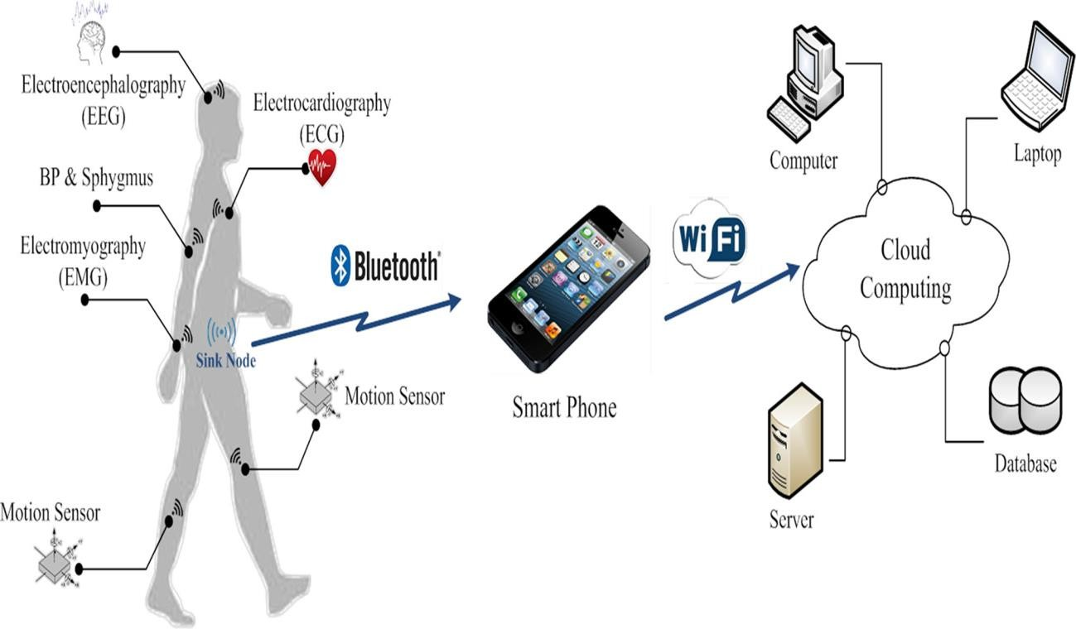

Fig.1-1[WBAN structural planning]

The rapid rise of population and the high cost of treatment have overcome the advances in microelectronics, wireless communications systems, and smart sensors, and has emerged a new generation of WBANs. The WBAN is a special-purpose network in which various sensors in different parts of the body monitor the body activities. Different sensors have been placed in different parts of the human body to collect critical and non-critical data in order to, collect data and send them to the central coordinator. The data are collected by the sensor nodes. This data is analyzed hence; the physiological activities and symptoms of the human body are monitored constantly. In some cases, data is critical and should be provided treatment to patients immediately to save them. For better quality service need proper energy consumption and delay efficiency.

## 1.2 WIRELESS BODY AREA NETWORKS

**BAN** consists of short-range devices with low level energy. It has various application which in the vicinity of human society. The applications aim medical services mostly), it also includes entertainment and gaming. In other words BANs is a unique Wireless Sensor Networks that has small number of nodes and has high reliability with much signifanct QoS as compared to the Traditional WSN.

**WBAN** is an assemblage of tiny, flexible behavioral, and low energy based wireless sensors to supervise any physiological changes around the human. In WBAN human wears some sensors which helps in monitoring the different parameters related to human health and then sends the accumulated information to a coordinator node or hub. This Coordinator node can either be a normal hub, or be a forwarder node that forwards data. Coordinator node further transmits monitored data to a main base station for processing through a wireless access point (AP). This AP can be a smart phone or can be a coordinator node itself as per the applications.

Sometimes sensor nodes have actuator to convert an electrical signal into physical signal like motion for pumping. A sensor in WBAN has a primary job to sense any change in physical, chemical or biological entities inside human or around its vicinity. Then they send the data for further treatment like filtering, amplifying or digitizing the signal for extracting the features. Then the processed signal is stored and further ready to be sent to the gateway through a wireless radio channel. This gateway or hub is a high power device used to gather and process the data transmitted by the sensor nodes. Hence the gateway should be capable of doing accurate computations.

### 1.2.1 Architecture of WBAN

Body area network is based on different attributes. Such as:

• Hardware platform

• BAN Communication Technology

• Sensors Distribution

• Physical environment

• Energy source

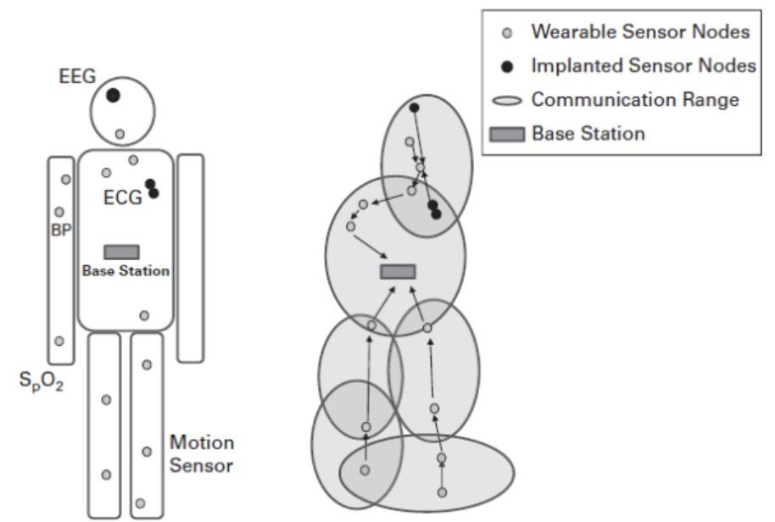

Fig. 1-2 [WBAN architecture]

### 1.2.2 Hardware platform

BAN contains several hardware components to fulfill variety of jobs. These hardware are according to their primary function and are as follows:

• It needs some general purpose sensor to measure and compare different human surrounding conditions.

• Then some medical equipments are employed to get information on health.

• To accumulate the information some data aggregator (image collector) are installed inside whole network

• Finally an access point or gateway (Smartphone) is required to store or communicate data.

### 1.2.3 BAN Communication Technology

Based on frequency of transmission, range and power consumption different types of communication technologies are coming forward. BAN has five layers in its protocol stack, but it has heavy application based on physical layer and medium access control layer. These layers do particular tasks to assure continuous communication within nodes and node to hub.

* The PHY layer acts according to radio frequency band and antenna specifications.
* MAC layer deals with communication strategies between lower PHY layers to upper layers.
* Network layer suggests reliable data exchange and control procedures.

### 1.2.4 Sensors Distribution

In BAN sensor distribution and installation is application basis and the purpose of node for the application. Sensors can be installed on or within the human body as per the application 12 requirements. For example, sensors are deployed to monitor or deliver medications to patients in health monitoring system. The figure below gives an idea of sensor deployment.

### 

### 1.2.5 Physical Environment

Though BAN has various applications, it is mainly focused on medical care system. Hence human body is mostly used physical environment. For sensor nodes environmental influence is a crucial part which depends on type of deployment also.

### 1.2.6 Energy Source

BAN devices have to be connected wirelessly to ensure mobility with no obstruction of movement, Thus, there should have wireless access between sensing nodes and hubs. To achieve smooth wireless communication nodes and hubs should have independent energy sources. The basic energy source in BAN system are Batteries. The batteries can be rechargeable or non-rechargeable based on the BAN application.

## 1.3 Application of BAN

The design of Body area networks (BANs) confines within the coverage region to the human body. The WBAN is an essential technology to realize convenient steady monitoring with the aid of disposing of physical wires. To maintain a good body alignment and BAN is applied in four primary ways. BAN is designed for both medical and non-medical application.

### 1.3.1 Medical

In late, the level of data gave and vitality assets fit for driving the sensors are progressing. Innovation has helped to evolve BAN technology in the advancement of medical field and give birth to telemedicine and health care systems. Essentially uses of BANs are relied upon to show up mostly in the social insurance area, particularly for ceaseless checking and several basic parameters of patients experiencing acute illnesses, Normally a BAN system is put on a patient to alarm the healing facility, even before they show at least a bit of kindness assault, through measuring changes in their basic signs. Figure 2-5 below shows the BAN medical scenario

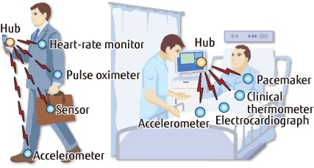

Fig. 1-3 [BAN for medical application]

## 1.4 Design Requirements

In WBANs, sensors collect various information from the patient body and communicate with the coordinator. For active patient health monitoring systems, Latency and transmission reliability are some of the crucial requirements. Similarly, WBANs requires high energy efficiency and scalability for long term monitoring.

### 1.4.1 Data rate

As body area network is an application based system, the data needed also varies for different applications. Hence data rate also varies from few Kbps to several Mbps according to the necessity level of applications. That means the emergency data packets to attain a serious condition have to have high data transmission rate with low latency.

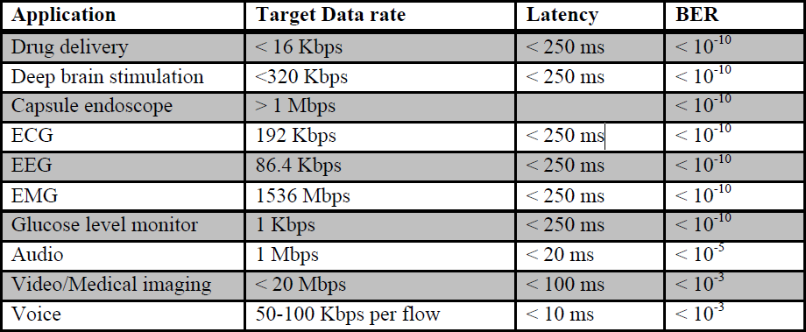

Table. 1-1 [WBAN application data rate ]

### 1.4.2 Energy Effective

Power effectivity is the first intention to acquire in WBANs as sensor nodes are fueled by small power batteries. So it is a dire requirement to minimize the power consumption for long term monitoring of health . Different dynamic energy management schemes can be implemented to increase the longevity of sensors.

### 1.4.3 Reliability

Reliability is the successful transmission of information through any channel. BAN mostly contains information regarding health issues which are necessary parameter for judging and medicating any disease. Hence BAN should have a greater reliability to be in the good book of everyone. This reliability depends on parameters like packets transmission delay and packet loss probability. Guessing of correct channel, packet dimension, and scheduling schemes at MAC layer can fortify reliability of BAN system.

### 1.4.4 Scalability

For BANs scalability is one of the common requirements. The hub quantity, to gather crucial and non-crucial life jeopardizing data, changes as indicated by patient checking necessities. Effortlessly setup of WBANs by including or evacuating sensor hubs is obliged to bolster adaptability. Mac layer can accomplish this flexibility.

### 1.4.5 Quality of Service (QoS)

BAN should be versatile enough to confirm various QoS levels to guarantee successful reception of information. QoS in BAN is a challenging issue to handle but this can be solved by coordinating network layers through different protocols. QoS entities vary from application to application according to importance level. Packets must be communicated in a reliable manner to get good QoS. And life endangering situations must be given high priority.

## 1.5 Cause Of Energy Wastage

Sensors used in BAN system have very small amount of battery power as it is mostly used around human. Hence replacement of batteries or recharging of batteries is quite impossible. As a result of restrained source, there ought to be strict management system to keep this energy wastage within limits. Therefore, it is a big issue for BAN sensor to minimize energy consumption.

**A. Collisions of packets** The transmission time and energy get wasted if nodes transmit data packets simultaneously at concurrent periods. This results due to heavy collision and interference between concurrent data packets arrived in same channel. At the receiver end, Collision of Packets 16 happens due to which there is packet loss and sender tries to resend the dropped or lost packets. This Retransmission of lost packets causes extra energy dissipation.

**B. Overhear of nodes** To avoid packet or data loss nodes try to overhear neighbor packets to resend on behalf of the sender. Acquiring and transmitting these extra packets cause extra energy consumption of nodes.

**C. Idle listening** In idle listening, sensors expect to listen other idle channels also which requires extra energy.

**D. Protocol overhead** If size of overhead increases it needs more energy to transmit large overhead packet State switching also causes additional energy consumption, which happens when a sensor node swaps its transceiver from sleep to active mode of transmitting information and then again to returns to sleep mode for preventing idle listen and overhear issues of system. In the subsequent chapters, different kind MAC protocols are discussed to make the procedure energy efficient.

## 1.6 Medium access control layer

The second lower layer above physical layer is medium access control (MAC) layer. This MAC layer is responsible for sharing of data and communication to the upper layer. The efficiency of sensitive wireless communication depends, on the extent, of the effectiveness of this l Medium access control (MAC) layer. Access the medium by the nodes is determined by a MAC protocol which controls the MAC layer operation.

### 1.6.1 Overview of IEEE 802.15.6 MAC Layer

This part talk about in regards to the WBAN MAC layer basics. It covers MAC layer frames as per exclusive WBAN physical layers. The nodes coordinate into single or multiple hops according to IEEE 802.15.6 standard, WBANs. A single coordinator or hub handles the overall operation of each WBAN network. The direct frame exchange between nodes and hub occurs in single-hopped star WBAN whereas relay nodes come to picture for star network.

### 1.6.2 Medium Access Control protocols

Our objectives in WBAN are as follows:

* Maximize throughput,
* Minimize the delay, and
* Maximize the network lifetime

These objectives above are achieved by commanding the sources of energy wastage that are discussed in the previous chapter.

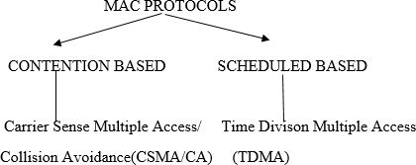To avoid the causes of energy degradation, the data transmission, and nodal behavior should be efficient which are handled by Medium Access Control (MAC) protocols. Protocols are sorted on the basis of contention and scheduling.

### 1.6.3 TDMA And CSMA/CA

**CSMA/CA**

* Nodes Compare for transmitting data.
* If the channel is busy, the node defers its transmission unless it turns into idle.
* Scalable without any time synchronization constraint.
* Uses significant protocol overhead.

**TDMA**

* Channel is slotted according to time which are assigned to nodes.
* Protocol are energy conserving.
* Duty cycle of radio is reduced.
* Hence, no contention, idle listening, overhearing problems. But these protocol require frequent synchronization.

Comparison between CSMA/CA access and TDMA access techniques are described in the table below.

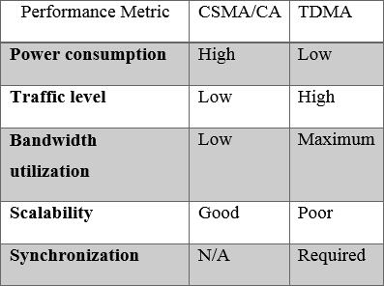

Table. 1-2 [CSMA/CA vs TDMA access protocol]

**CHAPTER 2**

# LITERATURE REVIEW

## 2.1 A SURVEY ON WIRELESS BODY AREA NETWORKS FOR EHEALTHCARE SYSTEMS IN RESIDENTIAL ENVIRONMENTS [1]

A typical health monitoring system consists of a network of wearable or implanted sensors that constantly monitor physiological parameters. Collected data are relayed using existing wireless communication protocols to a base station for additional processing. Simultaneously, public-funded healthcare systems in many developed countries are currently confronting an increase in the number of people diagnosed with chronic diseases such as obesity and diabetes. Therefore, healthcare systems are becoming unsustainable in their current form.

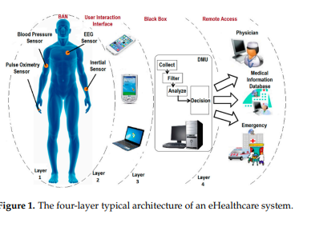

Intra-Body Communication (IBC) technology is one of the emerging possible solutions for providing an ultra-low power communication over very short range links that specifically target WBAN applications

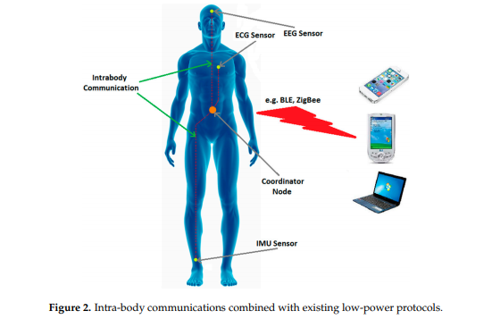

The current research in the area of WBANs with a specific focus on low-power consumption, transmission reliability, latency, data rates and security. A comparison of various energy-efficient.

## 2.2 PRIORITY BASED WIRELESS BODY AREA NETWORK WITH COGNITIVE RADIO [2]

a cognitive radio based coordinator node is designed for Wireless Body Area Networks and a data priority queue structure is constructed in the coordinator node. Cognitive Radio is capable of connecting various wireless access points with perception and adaptation features.Developed,modeled and simulated example network scenarios by using the Riverbed Modeler simulation software for this purpose. The prominent parameters user speed, access point delay, and connection cost are taken into account when selecting the wireless access point. In this way, the coordinator node provides to deliver data to the destination with priority and ensure to send data over optimum access point with minimum delay and cost.

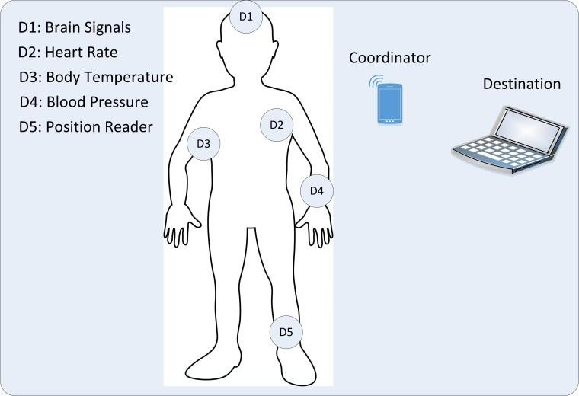

Fig.2-1 Wireless Body Area Network Structure

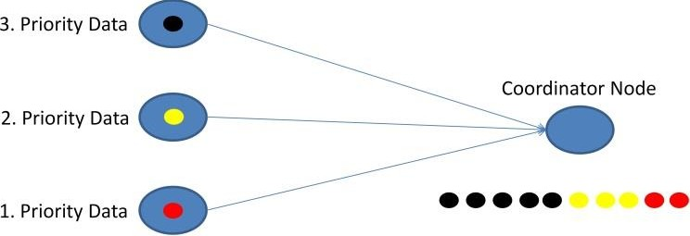

Fig.2-2 Data priority order in the coordinator node

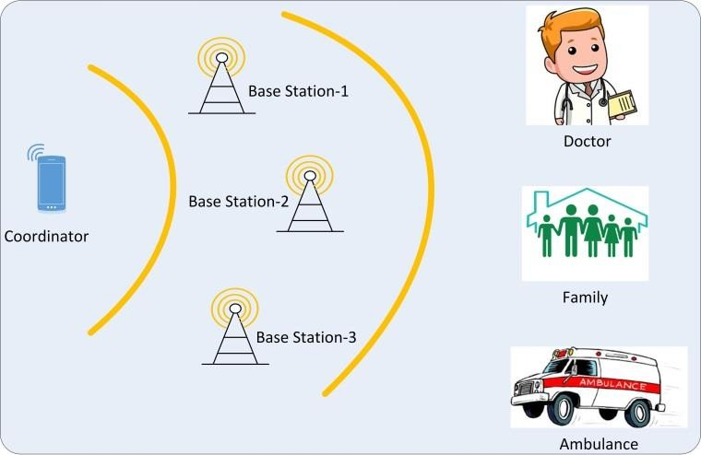

Fig.2-3 The designed WBAN structure

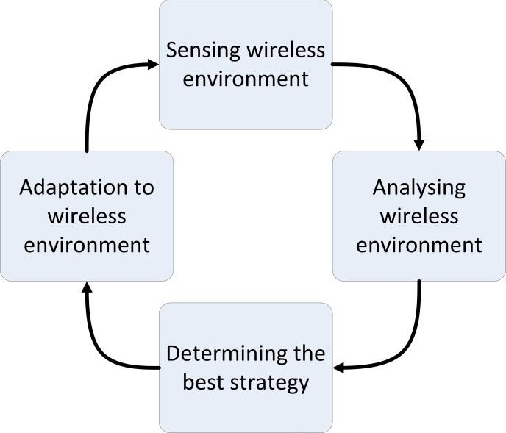

Fig.2-4 Cognitive radio cycle

2.2.1 summery In this study, a priority based wireless body area network with cognitive radio is proposed. There are three types of priority data in the network and the developed coordinator node sorts the data in its queue and sends them to the health center with minimum end to end delay. Also, the coordinator node in the proposed WBAN is designed with cognitive radio capabilities for adopting any access point around. A WBAN needs to stay connected to a local or a wide area network by using different wireless access points. Thus, the sorted data from body sensors in the coordinator node can be sent over optimum access point to the destination. As choosing the best serving access point has critical importance to provide quality of service support and cost efficient connections for WBAN users.

## 2.3 A PRIORITY-BASED ADAPTIVE MAC PROTOCOL FOR WIRELESS BODY AREA NETWORKS [3]

Standard protocols like the IEEE 802.15.4 cannot fulfill all the requirements. Many medium access control (MAC) protocols, mostly derived from the IEEE 802.15.4 superframe structure.. Nevertheless, they do not support a differentiated quality of service (QoS) for the various forms of traffic coexisting in a WBAN. In particular, a QoS-aware MAC protocol is essential for WBANs operating in the unlicensed Industrial, Scientific, and Medical (ISM) bands, because different wireless services like Bluetooth, WiFi, and Zigbee may coexist there and cause severe interference. propose a priority-based adaptive MAC (PA-MAC) protocol for WBANs in unlicensed bands, which allocates time slots dynamically, based on the traffic priority.

The IEEE 802.15.4 MAC protocol operates in three frequency bands: 16 channels in the 2.4 GHz Industrial, Scientific, and Medical (ISM) band, 10 channels in the 915 MHz ISM band, and 1 channel in the European 868 MHz band. In the IEEE 802.15.4, two operational modes are defined: the beacon enabled mode and the non-beacon enabled mode. In the beacon-enabled mode, the communication is synchronized and controlled by the network coordinator. In IEEE 802.15.4, if a node wants to reserve the resources for periodic traffic, it should first send a GTS request during the CAP with a CSMA/CA and the network coordinator will decide the GTS allocation accordingly.

## 2.4 ADAPTIVE MAC PROTOCOL DESIGN FOR ENERGY EFFICIENT AND RELIABLE WBAN LINK [4]

Wireless body area network is an emerging field of a wireless sensor network that works in the vicinity of the human body. This technology has its most significant application in the modern healthcare system. This WBAN architecture is designed to get the health information and daily routine of human activity (both physical and psychological) through energy efficient and reliable radio transceivers connectivity These modern devices behave according to some predesigned rules called communication protocols. The MAC protocols are designed specially according to WBAN standards and requirements.

The physiological sensors installed in WBAN system consume a large amount of energy for communication that leads to frequent data interruption and also a change of implanted devices. As this is troublesome for both patient and server, protocols are continuously upgraded to make the communication highly energy efficient and reliable.

The prime aim of this work is to reduce the energy consumption and increase the lifespan of the network. This work proposes an energy harvesting adaptive MAC protocol applied for node connectivity and detailed simulation study carried out with the proposed protocol proves to be having minimum power consumption, increased network lifetime, and high throughput compared to the existing MAC protocols in WBAN framework. We have used Hybrid mesh topology where all nodes have both uplink and downlink. Here we are utilizing a GTS based multi-hop technique and adaptive wake-up mechanism for the sleep mode of the transceiver to minimize the wake-up periods.

### 2.4.1 Description

Our aim is to get higher throughput with minimum energy consumption, so as to make WBAN network to be more reliable.

Let the energy consumed by transceiver during one cycle:

Ec = Esl + Eac

The above expression describes the energy consumption of one cycle which equals to the total energy consumed during sleep mode (Esl) and active mode (Eac) by the sensor. We accentuate an adaptive approach to minimize active energy consumption by avoiding unnecessary wakeups. As a result, the proposed scheme attains energy efficiency and higher throughput.

### 2.4.2 Frame structure

We are considering the MAC frame structure as described in fig.5-2. The frame contains preamble, data and control packets, and it uses CAP for emergency requests. Data packet consists of information to be sent and also time slots which include both assigned time slot and guard period. Control packet is of several types.

*Channel Packet*: It contains unique address ID and channel information which is broadcasted after channel selection.

*Time slot request packet (TSR):* This packet asks for guaranteed time slot to the sink

*Slot request-reply packet (SRR):* Sink responses to the application and packet carries assigned time slot information.

*Synchronization-Acknowledgement Packet:* This packet contains the required drift value for future synchronization to the previously received data packet.

*Data Request (DR):* sender node sends a packet to satisfy the traffic demand for the link.

*Acknowledgment packet (ACK):* This packet is sent to acknowledge the reception of data packet.

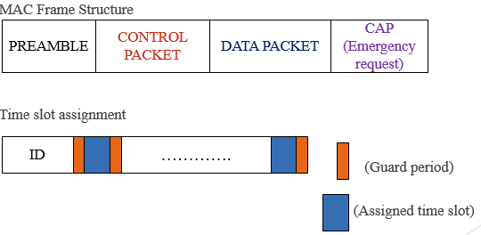

Fig.2-5 [MAC frame and time slot]

## 2.5 A PRIORITY BASED MAC PROTOCOL FOR ENERGY CONSUMPTION AND DELAY GUARANTEED IN WIRELESS BODY AREA NETWORKS [5]

Wireless body area networks (WBANs) consist of tiny sensors that placed around or implant in the human body. In WBANs, the main challenge is delay and limitations of energy consumption to prolong the network lifetime. In this context, a MAC protocol has been provided to guarantee energy consumption and delay reduction based on priority of data traffic. The design of this protocol consisted of four sections:

First, the patient data traffic is prioritized and classified, which included normal data periodic data, and emergency data

Second, the super frame structure is improved according to IEEE 802.15.4 and the priorities for the data are optimized.

Third, the energy consumption and delay have been reduced by using the radio wake-up mechanism and through controlling the node modes.

Four, for checking the node modes, the state diagram and the asymmetric hidden Markov method have been exploited to model the limited capacity of the bufers.

### 2.5.1 Data Type

There are two kinds of data trafc on WBANs: crucial and non-crucial data trafc. A prioritization mechanism is provided when data needs to be transferred immediately for organizing and transmitting data. Therefore, the priority service must frst be considered. In this

Table 2-1 Different levels of trafc priority

|  |  |  |  |
| --- | --- | --- | --- |
|  | Priority | Traffic category | Example |
| ED | P0 | Emergency | Emergency alarm signal, life critical emergency data(vital) |
| PD | P1 | Periodic | Continuous medical signal (ECG, EEG, EMG…) |
| ND | P2 | Normal | Discontinuous medical signal (temperature, glucose level, SPO…) |

regard, three types of data have been defined in this paper: ND, PD, and ED. The emergency data traffic has been considered in this study. When transmitting ED, the data must be transferred with no delay. So, the data should be categorized according to the data rate and packet size and prioritized for transmission. Delay and reliability should be taken into account as well. For example, ECG data have a high priority. Change in the behavior and the normal process of data cause a threat the patient’s life. For instance, ED in a normal situation with very low or high temperature or pressure and humidity, etc., can suddenly change. In these circumstances, the corresponding data should be collected in the environment with the highest quality of service without loss of packet or delay by considering effective energy. Due to the heterogeneous nature of patient data, it is necessary to send the data immediately to the body coordinator sensor without collision, delay, and loss of the packet, with minimal energy consumption. In this paper, the data have been classified based on the type of data and traffic and provided an optimal solution with a super frame structure.

### 2.5.2 Data Priority Classification

Prioritization mechanisms for networks with heterogeneous trafc loads or containing emergency data are required to guarantee quality of service. Three types of data have been suggested by this system. ND, PD, and ED, are determined by Data Normal, Data Periodic, Data Emergency, respectively. Resources are assigned to nodes according to these priorities. The following Table 1 illustrates the priority of data based on the delay priority.

The priority for each data is calculated by the Eq. 1:

Priority = Data type/(λt × Psize)

λT and Psize are traffic generation rate and the length of the data packet generated for each sensor of the body, respectively. Low traffic rates and a small packet size increase the priority of sending packets. However, if more data packets are needed for small-size, transmissions the success rate may be lower than of the larger data packet transfer rates. In the ED packets, the highest traffic generation rate has the higher priority for sending. That is, the data must be sent without delay and real-time.

### 2.5.3 Superframe Structure

In WBANs, MAC protocols in the IEEE 802.15.4 standard perform two operations: the beacon enabled mode and the non-beacon enable mode. In the beacon mode, the communication is controlled by the coordinator, which includes network control and synchronization data. A superframe includes active or inactive periods, with the active part

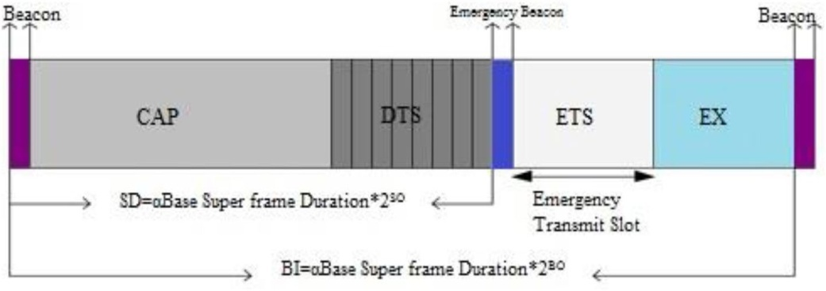

Fig. 2-6 superframe structure of ECTP-MAC protocol

consisting of the three parts of the beacon, CAP, and CFP. The CFP consist of 7 guaranteed time slots (GTS). The CFP and CAP use the TDMA mechanism and the CSMA/ CA method, respectively. All communications must take place in the active period, and in the inactive period, devices can sleep and save energy. The superframe structure consists of two parameters, the superframe order (SO) and the beacon order (BO). In the SO and BO sections, the length of the superframe duration (SD) and the beacon interval (BI) are expressed, respectively.

### 2.5.4 Backof Period

The nodes start transmitting when the timer is zero. The nodes frst listen to the channel before transmit and then if the channel is idle, they send the request to send (RTS) message to the destination. If the channel was busy, the nodes would perform wait for a random backof time process in CAP. The nodes again listen to the channel after a random time. The random backof time is calculated based on the priority in Eq. 1. If the channel was busy again, the node will wait for a unit backof. This fow continues up to macMAX backof limits. The receiving node sends a clear to send (CTS) to the sender node, then it delivers the data. Furthermore, the destination node sends ACK message to the sender node. At the end, the user sends the request for packet control. When the node bufer was empty, nodes attempts to transmit data to the channel. After sending the packet, the data is deleted from the bufer. This operation is summarized in the following fow chart in Fig. 2. This fow chart depicts the general behavior of the system with limitations on the number and location of the nodes.

### 2.5.5 Normal Data

Physiological data in normal body conditions such as body temperature and glucose levels are transmitted in ND. These data are sent in the CAP section with the CSMA/CA mechanism. The nodes check the channel frst, if the channel was idle, data would be sent, however if the channel was busy, the node would wait for a random backof time. In addition, any unsuccessful attempt to access the backof time channel in IEEE 802.15.4 standard requires additional energy to access the channel. After this time, the nodes access the channel again and the data are transmitted. In this type of data, considering delay and reliability is not important.

### 2.5.6 Periodic data

Periodic data are sent based on the type of data that the doctor needs as audio or video data after intervals of time. These data do not have the limitation of delays. The nodes are transmitted in the DTS part of the superframe. In this part, the coordinator uses the TDMA to send nodes.

### 2.5.7 Emergency data

Emergency trafc occurs randomly, and the size of the packets is usually the same with other normal packets. Emergency data are transmitted with higher priority and smaller backof in shorter periods of time. If the channel is busy, the sensor nodes will have access to the channel for more backof time, causing long delays in channel access.

ED is handled by a central coordinator to manage the requests of nodes. A node with a higher priority data access the channel to transmit the data to the central coordinator and after transmission the nodes, switch to sleep, hence, lead to saving energy and reducing energy consumption.

**CHAPTER 3**

# RESEARCH METHODOLOGY

## 3.1 Introduction

As it is mentioned in the title, this chapter includes the research methodology of the thesis. , in this part the author outlines the research strategy, the research method, the research approach, the methods of data collection, the selection of the sample, the research process, the type of data analysis, the ethical considerations and the research limitations of the project.

## 3.2 Research strategy

The research held with respect to this thesis was an applied one, but not new. Rather, numerous pieces of previous academic research exist regarding Designing A priority based load adaptive MAC protocol based on **Cognitive Radio** in WBAN. As such, the proposed research took the form of a new research but on an existing research subject.

## 3.3 Research method – Qualitative versus Quantitative techniques

So as to fulfill the destinations of the thesis, a qualitative research was held. The principle normal for qualitative research is that it is generally fitting for little examples, while its results are not quantifiable and quantifiable . Its basic advantage, which also constitutes its basic difference with quantitative research, is that it offers a complete description and analysis of a research subject, without limiting the scope of the research and the nature of participant’s responses. It is more appropriate for small samples.

## 3.4 Research approach

The research approach that was pursued for the reasons for this research was the inductive one. As indicated by this methodology, researchers start with explicit perception, which are utilized to deliver summed up hypotheses and ends drawn from the exploration. The explanations behind possessing the inductive methodology was that it considers the setting where research exertion is dynamic, while it is likewise most suitable for little examples that produce subjective information.

## 3.5 Data collection method and tools

For the purposes of this research, we collected data from some previous research paper. We use online for collecting huge amount of data.

## 3.6 Data analysis

Content analysis was used to analyze the data which was gathered from previous related papers. A main advantage of content analysis is that it helps in data collected being reduced and simplified, while at the same time producing results that may then measured using quantitative techniques. Moreover, content analysis gives the ability to researchers to structure the qualitative data collected in a way that satisfies the accomplishment of research objectives.

## 3.7 Ethical considerations

The current study was subject to certain ethical issues.. At the same time, we collected data from some paper with confidence that we will not use any information of them without giving their credit. And we will also keep the important information safe.

**CHAPTER 4**

# RESULT AND DISCUSSION

## 4.1 Proposed Protocol

In existing protocol used a superframe structure where this structure has two main phases.

**Phase one:** First phase consist of CAP for periodic data(PD) and DTS for normal data(ND). This phase slotted only for periodic and normal data no emergency data come within this phase. For the emergency data there is no slot or contention mechanism for ED. It has a dedicated slot.

**Phase two:** Emergency Transmit Slot(ETS) only for emergency data(ED). Beacon only take emergency data from several node and send it to coordinator to schedule all the data. When ED has no data then it goes into sleep state.

As in the first phase only for PD and ND if during that time any ED comes then it should wait for the second phase. There is no chance to compare ED with PD and ND that the reason for occurring some delay.

Now our goal is to work on the first phase where ED also can compare with PD and ND in a give priority range. As we assume for 16 window size, so for ED –> 0~3 and for PD+ND –> 4~15 here ED get the highest priority. Based on the number of node window size may change like- 16, 32, 64, 128. According to the window size slot ranges will also change. But if ED is not capable to send data within first phase then go for its dedicated slot ETS. As ED has the access in first phase it will reduce delay.

### 4.1.2 Proposed Superframe Structure

ETS CAP DTS ETS EX

Beacon Emergency Beacon Beacon

Emergency Transmit Slot

BI= aBase Superframe Duration*2BO

SD= aBase Superframe Duration*2SO

Fig. 4-1 The proposed superframe structure

### 4.1.3 Algorithm of the proposed protocol

**Phase 1:**

Beacon by coordinator node

Increase CW to 32

Take backoff

8-31(32)

Sleep

Send data

Success

Take backoff

4~15(16)

If

ND/PD

Phase 2

Success

Send data

Take backoff

0~3(16)

If

ED

**Y Y**

**N N**

**Y**

**N**

**Y**

**N**

**Phase 2:**

Slot Allocation

Phase 1

Sleep

Send ED in dedicated slot

Allocated slot

Received by ED node

Emergency Beacon

**Y**

**N**

**CHAPTER 5**

# CONCLUSION

By considering the particular qualities and necessities of WBANs and the assorted variety of utilizations and advantages of utilizing these systems, and given that none of the current conventions could meet the prerequisites of the WBANs. A MAC convention was proposed in the present examination as per various necessities of these systems, for example, low vitality utilization, least delay in information transmission, especially for crisis information, and the prioritization of crisis information and effective utilization of the channel. The proposed MAC convention is called ECTP-MAC and is organized dependent on information traffic, in which information are transmitted dependent on need as ordinary information, intermittent information, and crisis information. To transmit typical information, the CSMS/CA system is utilized to move information dependent on the TDMA schedule opening. Moreover, to transmit the crisis information the focal facilitator performs information move by utilizing an additional stage and the inert period of super frame is proficiently utilized. Additionally, in our structure the length of bakeoff time to change determined by the information payload.

At last, intermittent information are transmitted regularly with no interruptions. The topsy-turvy shrouded Markov model was utilized to look at and examine hubs. This model can show all models precisely. Moreover, this model demonstrates the probabilities of body hubs for various models during the transmission of various information with the transmission probabilities. Based on the reenactment results, ECTP-MAC demonstrates an improvement in vitality utilization and postponements, just as execution and lifetime contrasted with past conventions. Later on, the scientists in this examination will test the MAC convention for the transmission of crisis information on genuine applications. Since the transmission of crisis information is as yet one of the fundamental difficulties, as an expectation of the event of a crisis information in information transmission in a cycle is troublesome. In this manner, ascertaining channel get to potential outcomes to each body sensor lessens the transmission time of basic information.

# REFERENCES

1. IEEE 802.15.4. (2006). IEEE Standard for Information Technology 802.15.4, Wireless Medium

Access Control (MAC) and Physical Layer (PHY) Specifcations for low-rate wireless personal area

networks (LR-WPANs). New York, NY: The Institute of Electrical and Electronics Engineers, Inc.

2. Zhou, J., Guo, A., Xu, J., & Su, S. (2014). An optimal fuzzy control medium access in wireless

body area networks. Neurocomputing, 142, 107–114.

3. Yoon, J. S., Ahn, G.-S., Joo, S.-S., & Lee, M. J. (2010). PNP-MAC: Preemptive slot allocation and

non-preemptive transmission for providing QoS in body area networks. In 2010 7th IEEE consumer

communications and networking conference (pp. 1–5).

4. Liu, B., Yan, Z. S., & Chen, C. W. (2013). MAC protocol in wireless body area networks for

E-health: Challenges and a context-aware design. IEEE Wireless Communication, 20, 64–72.

5. Antoni, M., Alejandro, C., Marc, B., & Lopez, V. (2016). Data aggregation and principal component analysis in WSNs. IEEE Transactions on Wireless Communication, 15, 3908–3919.

6. Asemani, M., & Esnaashari, M. (2015). Learning automata based energy efcient data aggregation

in wireless sensor networks. Wireless Network, 21, 2035–2053.

7. Mouzehkesh, N., Zia, T., Shafgh, S., & Zheng, L. H. (2015). Dynamic backof scheduling of low

data rate applications in wireless body area networks. Wireless Networks, 21, 2571–2592.

8. Latre, B., Braem, B., Moerman, I., Blondia, C., & Demeester, P. (2011). A survey on wireless body

area networks. Wireless Networks, 17(1), 1–18.

9. Laufer, R., & Kleinrock, L. (2016). The capacity of wireless CSMA/CA networks. IEEE/ACM

Transactions on Networks, 24, 1518–1532.

10. Sasaki, M., Furuta, T., Ukai, T., & Ishizaki, F. (2016). TDMA scheduling problem avoiding interference in multi-hop wireless sensor networks. Journal of Advanced Mechanical Design, Systems,

and Manufacturing, 10(3). https://doi.org/10.1299/jamdsm.2016jamdsm0047.

11. Feng, L., Yu, J. G., Cheng, X. Z., & Wang, S. L. (2016). Analysis and optimization of delayed channel

access for wireless cyber-physical systems. EURASIP Journal on Wireless Communication and Network,

https://doi.org/10.1186/s13638-016-0557-9.

12. Yu, J. G., Huang, B. G., Cheng, X. Z., & Atiquzzaman, M. (2017). Shortest link scheduling algorithms in wireless networks under the SINR model. IEEE Transactions on Vehicular Technology,

66, 2643–2657.

13. Akbar, M. S., Yu, H. N., & Cang, S. (2016). Delay, reliability, and throughput based QoS profle: A

MAC layer performance optimization mechanism for biomedical applications in wireless body area

sensor networks. Journal of Sensors. https://doi.org/10.1155/2016/7170943.

14. Gama, O., & Simoes, R. (2014). A hybrid MAC scheme to improve the transmission performance

in body sensor networks. Wireless Personal Communication, 80, 1263–1279.

15. Ullah, S., Imran, M., & Alnuem, M. (2014). A hybrid and secure priority-guaranteed MAC protocol for wireless body area network. International Journal of Distributed Sensor Networks. https://

doi.org/10.1155/2014/481761.

16. Sarkar, S., Misra, S., Bandyopadhyay, B., Chakraborty, C., & Obaidat, M. S. (2015). Performance

analysis of IEEE 802.15.6 MAC protocol under non-ideal channel conditions and saturated trafc

regime. IEEE Transactions on Computers, 64, 2912–2925.